HOMOMORPHIC FILTERING (GAUSSIAN FILTER)

import cv2

import numpy as np

import matplotlib.pyplot as plt

def normalize(img):

nImg = np.zeros(img.shape)#, dtype='uint8')

max_ = img.max()

min_ = img.min()

for i in range(img.shape[0]):

for j in range(img.shape[1]):

nImg[i][j] = (img[i][j]-min_)/(max_-min_) * 255

return np.array(nImg, dtype='uint8')

def gaussianhomomorphic(gl, gh, c, d0, shape):

im_H = shape[0]

im_W = shape[1]

centerx = im_H//2

centery = im_W//2

g = np.zeros((shape),np.float32)

ds = d0**2

for i in range(im_H):

for j in range(im_W):

u = i - centerx

v = j - centery

a = 1 - np.exp(((-c*(u**2+v**2))/ds))

g[i,j] = (gh - gl) * a + gl

return g

img = cv2.imread('prova.jpg',0)

logimage = np.log1p(img)

f = np.fft.fft2(logimage)

fshift = np.fft.fftshift(f)

magnitude = np.abs(fshift)

phase = np.angle(fshift)

gl = 0.5, gh = 1.2, c = 0.1, d0 = 50

shape = img.shape

ffilter = gaussianhomomorphic(gl, gh, c, d0, shape)

newmagnitude = np.multiply(magnitude,ffilter)

newimg = np.multiply(newmagnitude,np.exp(1j*phase))

spatialoutput = np.real(np.fft.ifft2(np.fft.ifftshift(newimg)))

output = np.expm1(spatialoutput)

plt.imshow(output,gray)

plt.show()

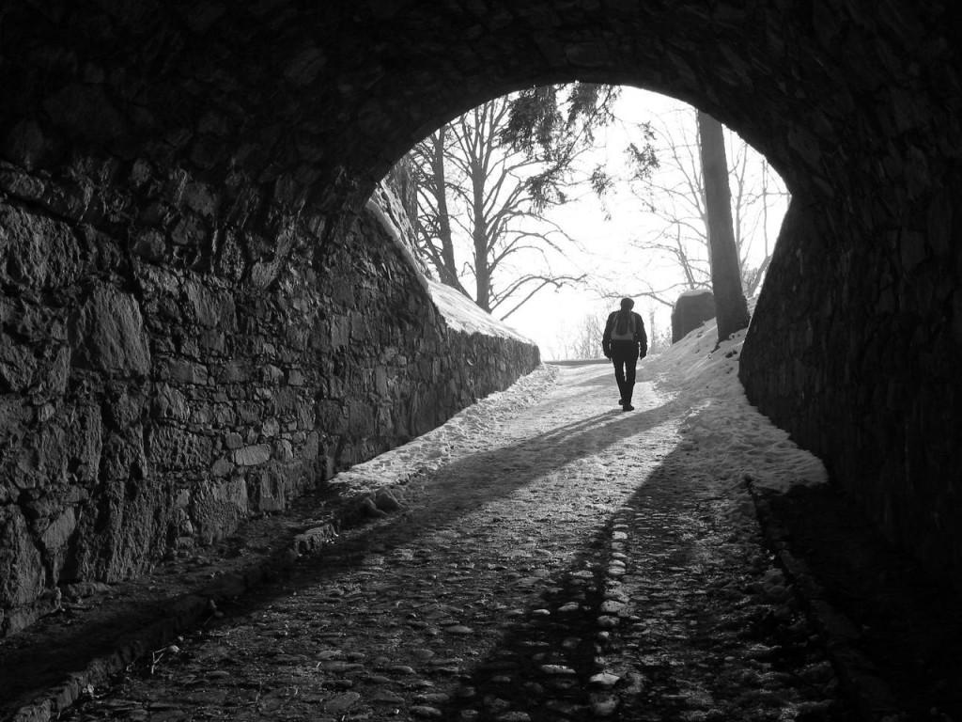 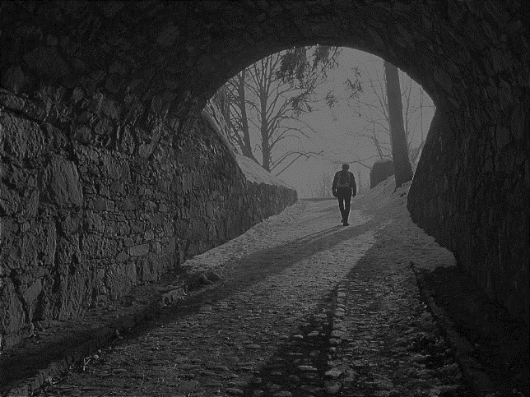

Fig1.1: Input Image Fig1.2:Output Image

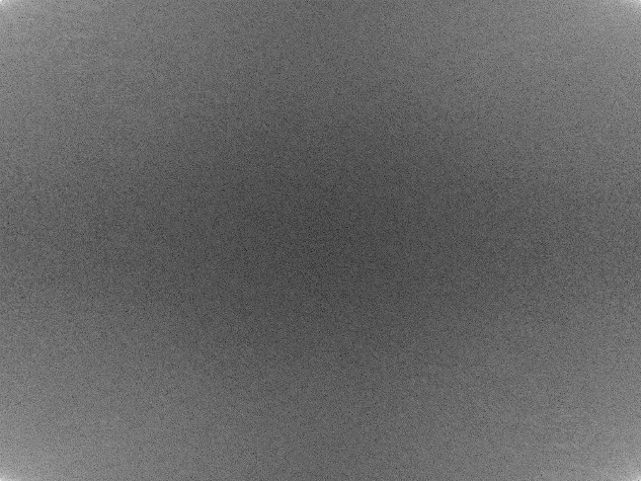 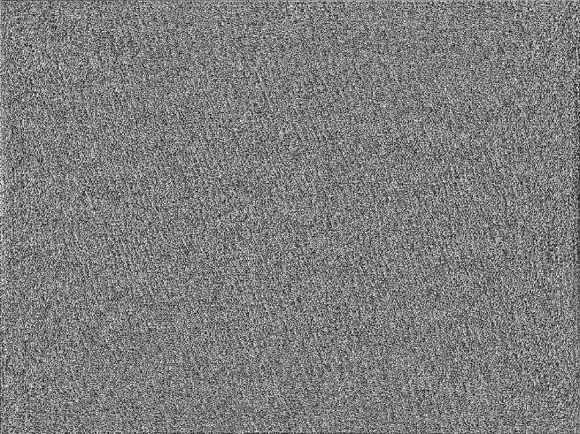

Fig1.3: Magnitude Spectrum Fig1.4: Phase

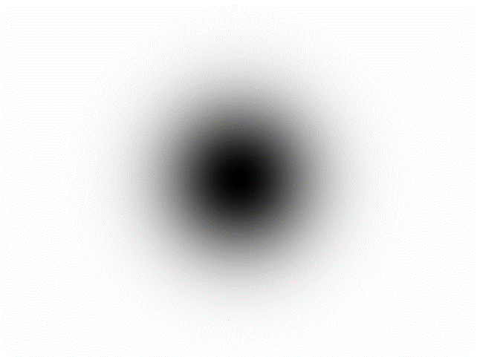 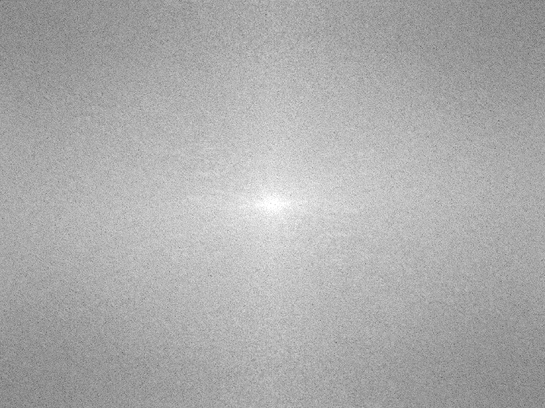

Fig1.3: Gaussian Kernel Fig1.4: Center Shifted Magnitude

INVERSE FILTERING

import cv2

import numpy as np

import matplotlib.pyplot as plt

def normalize(img):

nImg = np.zeros(img.shape)#, dtype='uint8')

max_ = img.max()

min_ = img.min()

for i in range(img.shape[0]):

for j in range(img.shape[1]):

nImg[i][j] = (img[i][j]-min_)/(max_-min_) * 255

return np.array(nImg, dtype='uint8')

def zero_pad(image, shape, position='corner'):

shape = np.asarray(shape, dtype=int)

imshape = np.asarray(image.shape, dtype=int)

if np.alltrue(imshape == shape):

return image

if np.any(shape <= 0):

raise ValueError("ZERO_PAD: null or negative shape given")

dshape = shape - imshape

if np.any(dshape < 0):

raise ValueError("ZERO_PAD: target size smaller than source one")

pad_img = np.zeros(shape, dtype=image.dtype)

idx, idy = np.indices(imshape)

if position == 'center':

if np.any(dshape % 2 != 0):

raise ValueError("ZERO_PAD: source and target shapes have different parity.")

offx, offy = dshape // 2

else:

offx, offy = (0, 0)

pad_img[idx + offx, idy + offy] = image

return pad_img

def psf2otf(psf, shape):

if np.all(psf == 0):

return np.zeros_like(psf)

inshape = psf.shape

# Pad the PSF to outsize

psf = zero_pad(psf, shape, position='corner')

f = np.fft.fft2(psf)

otf = np.fft.fftshift(f)

return np.abs(otf)

def butterworth(d0,n,shape):

im_H = shape[0]

im_W = shape[1]

centerx = im_H//2

centery = im_W//2

g = np.zeros((shape),np.float32)

for i in range(im_H):

for j in range(im_W):

u = i - centerx

v = j - centery

p = 1+(((u**2+v**2)**0.5)/d0)**(2*n)

q = 1/p

g[i,j] = q

return g

def motion_blurr(img):

im_H = img.shape[0]

im_W = img.shape[1]

ksize = 5

padding = (ksize-1)//2

img = cv2.copyMakeBorder(img, padding, padding, padding, padding, cv2.BORDER_REPLICATE)

output_H = (im_H + ksize-1)

output_W = (im_W + ksize-1)

result = np.zeros((output_H,output_W),np.float32)

motion_blurr_filter = np.array([[1,0,0,0,0],

[0,1,0,0,0],

[0,0,1,0,0],

[0,0,0,1,0],

[0,0,0,0,1]])

for x in range(padding,output_H-padding):

for y in range(padding,output_W-padding):

a = 0

for i in range(-padding,padding+1):

for j in range(-padding,padding+1):

a += motion_blurr_filter[i+padding,j+padding]*img[x-i,y-j]

result[x,y] = a/5

result[x,y] /= 255

return (result,motion_blurr_filter)

img = cv2.imread('lena.png',0)

blurred_image,psf = motion_blurr(img)

f = np.fft.fft2(blurred_image)

fshift = np.fft.fftshift(f)

magnitude = np.abs(fshift)

phase = np.angle(fshift)

shape = blurred_image.shape

otf = psf2otf(psf,blurred_image.shape)

newmagnitude = magnitude/otf

d0 = 52, n = 2

bfilter = butterworth(d0, n, shape)

newmagnitude *= bfilter

newimg = np.multiply(newmagnitude,np.exp(1j*phase))

spatialoutput = np.real(np.fft.ifft2(np.fft.ifftshift(newimg)))

plt.imshow(spatialoutput,’gray’)

plt.show()

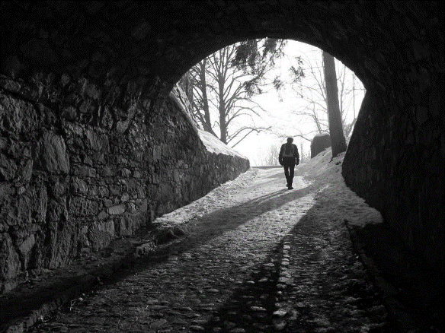 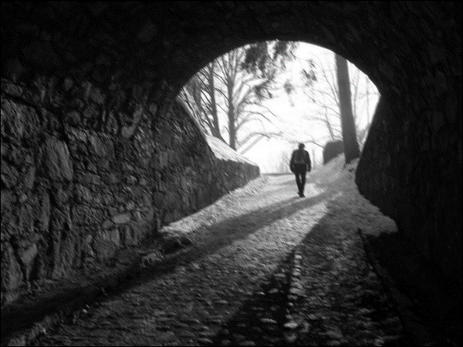

Fig2.1: Input Image Fig2.2: Blurred Image

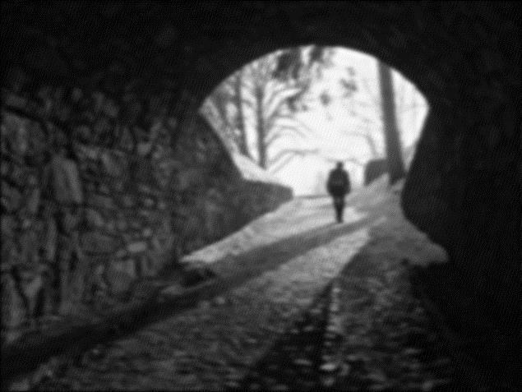

Fig2.3: Restored Image